CPE301 – SPRING 2019

Design Assignment 2B

Student Name: Geovanni Portillo

Student #: 8000603824

Student Email: [portig1@unlv.nevada.edu](mailto:portig1@unlv.nevada.edu)

Primary Github address: <https://github.com/portig1/submissions_E>

Directory: submissions_E/DA/LAB2B/

Submit the following for all Labs:

1. In the document, for each task submit the modified or included code (only) with highlights and justifications of the modifications. Also, include the comments.
2. Use the previously create a Github repository with a random name (no CPE/301, Lastname, Firstname). Place all labs under the root folder ESD301/DA, sub-folder named LABXX, with one document and one video link file for each lab, place modified asm/c files named as LabXX-TYY.asm/c.
3. If multiple asm/c files or other libraries are used, create a folder LabXX-TYY and place these files inside the folder.
4. The folder should have a) Word document (see template), b) source code file(s) and other include files, c) text file with youtube video links (see template).

1. **COMPONENTS LIST AND CONNECTION BLOCK DIAGRAM w/ PINS**

Atmel Studio 7

ATmega328PB Xplained mini

Multi-function Shield

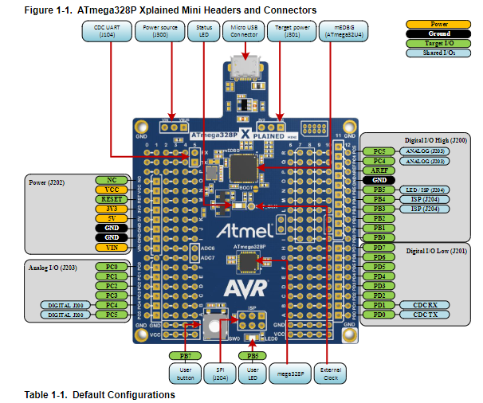

Tied a wire to PD2 to be able to press to GND to active INT0

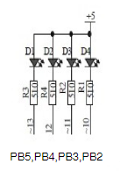

Multifunction Shield LED schematic

1. **INITIAL/MODIFIED/DEVELOPED CODE OF TASK 1/Assembly**

.ORG 0 ;location for reset

JMP MAIN

.ORG 0x02 ;location for external interrupt 0

JMP EX0_ISR

MAIN:

LDI R20, HIGH(RAMEND)

OUT SPH, R20

LDI R20, LOW(RAMEND)

OUT SPL, R20 ;initialize stack

SBI DDRB, 2 ;PORTB.2 = output

SBI PORTB, 2 ;Turn off LED (reverse logic)

SBI PORTD, 2 ;pull-up activated

LDI R20, 0x2 ;make INT0 falling edge triggered

STS EICRA, R20

LDI R20, 1<<INT0 ;enable INT0

OUT EIMSK, R20

SEI ;enable interrupts

HERE:JMP HERE

EX0_ISR:

CBI PORTB, 2

RCALL delay1250ms

SBI PORTB, 2

RETI

delay1250ms:

;Taken from DA2A, Task 2

;Delay function is meant to have a delay of approximately 1250ms for a clock at 16MHz

;Delay function from delayL0 and below takes 120,603 clock cycles

;Clock cycles total needed are 20,000,000 and require 165.8 iterations rounded up

;However, when running on hardware the time it takes for the delay is about twice as long when the delay is in the

;interrupt. To mitigate this I have halved the 166 to 83 and that gives about 1.250s

LDI R19, 83

delayL0_A: LDI R20, 200

delayL1_A: LDI R21, 200

delayL2_A: DEC R21

BRNE delayL2_A

DEC R20

BRNE delayL1_A

DEC R19

BRNE delayL0_A

1. RET **INITIAL/MODIFIED/DEVELOPED CODE OF TASK 1/C Code**

int main(void)

{

DDRB |= (1 << 2); //PB2 as output

PORTB |= (1 << 2); //Turn off LED (reverse logic)

PORTD |= (1 << 2); //Pull-up activated

EICRA = 0x02; //Make INT0 falling-edge triggered

EIMSK = (1 << INT0); //enable external interrupt 0

sei(); //enable interrupts

while(1) {

}

}

ISR (INT0_vect) { //ISR for external interrupt 0

PORTB = (0 << 2); //Turn on

/* For a counter set to 16,000,000 it takes 6s to complete and using that ratio and knowing I need a delay of 1.25s, I calculated

that the counter needs to be set at 3,333,333. However, when running on hardware with this loop in the interrupt, the delay takes about

twice as long to complete. So for this I halved 3,333,333 to 1,666,667 to get the 1.250s delay*/

long i; //initialize i for counter

i = 1666667;

while (i > 0) {

i--;

};

PORTB = (1 << 2); //Turn off

}

1. **SCHEMATICS**

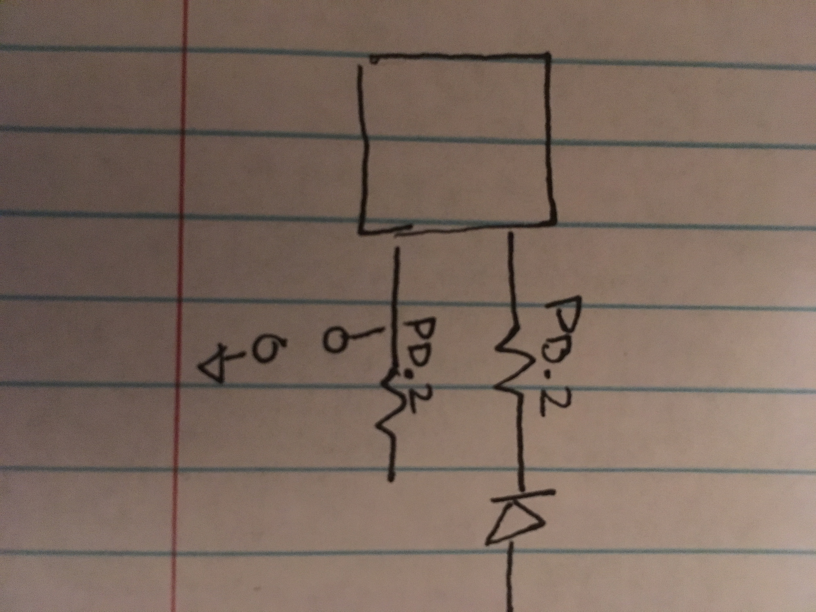

Schematic showing connections for PORTB.2 and PORTD.2 (INT0) which needed to be grounded to activate

1. **SCREENSHOTS OF EACH TASK OUTPUT (ATMEL STUDIO OUTPUT)**

Not asked for in Design Assignment 2A instructions

1. **SCREENSHOT OF EACH DEMO (BOARD SETUP)**

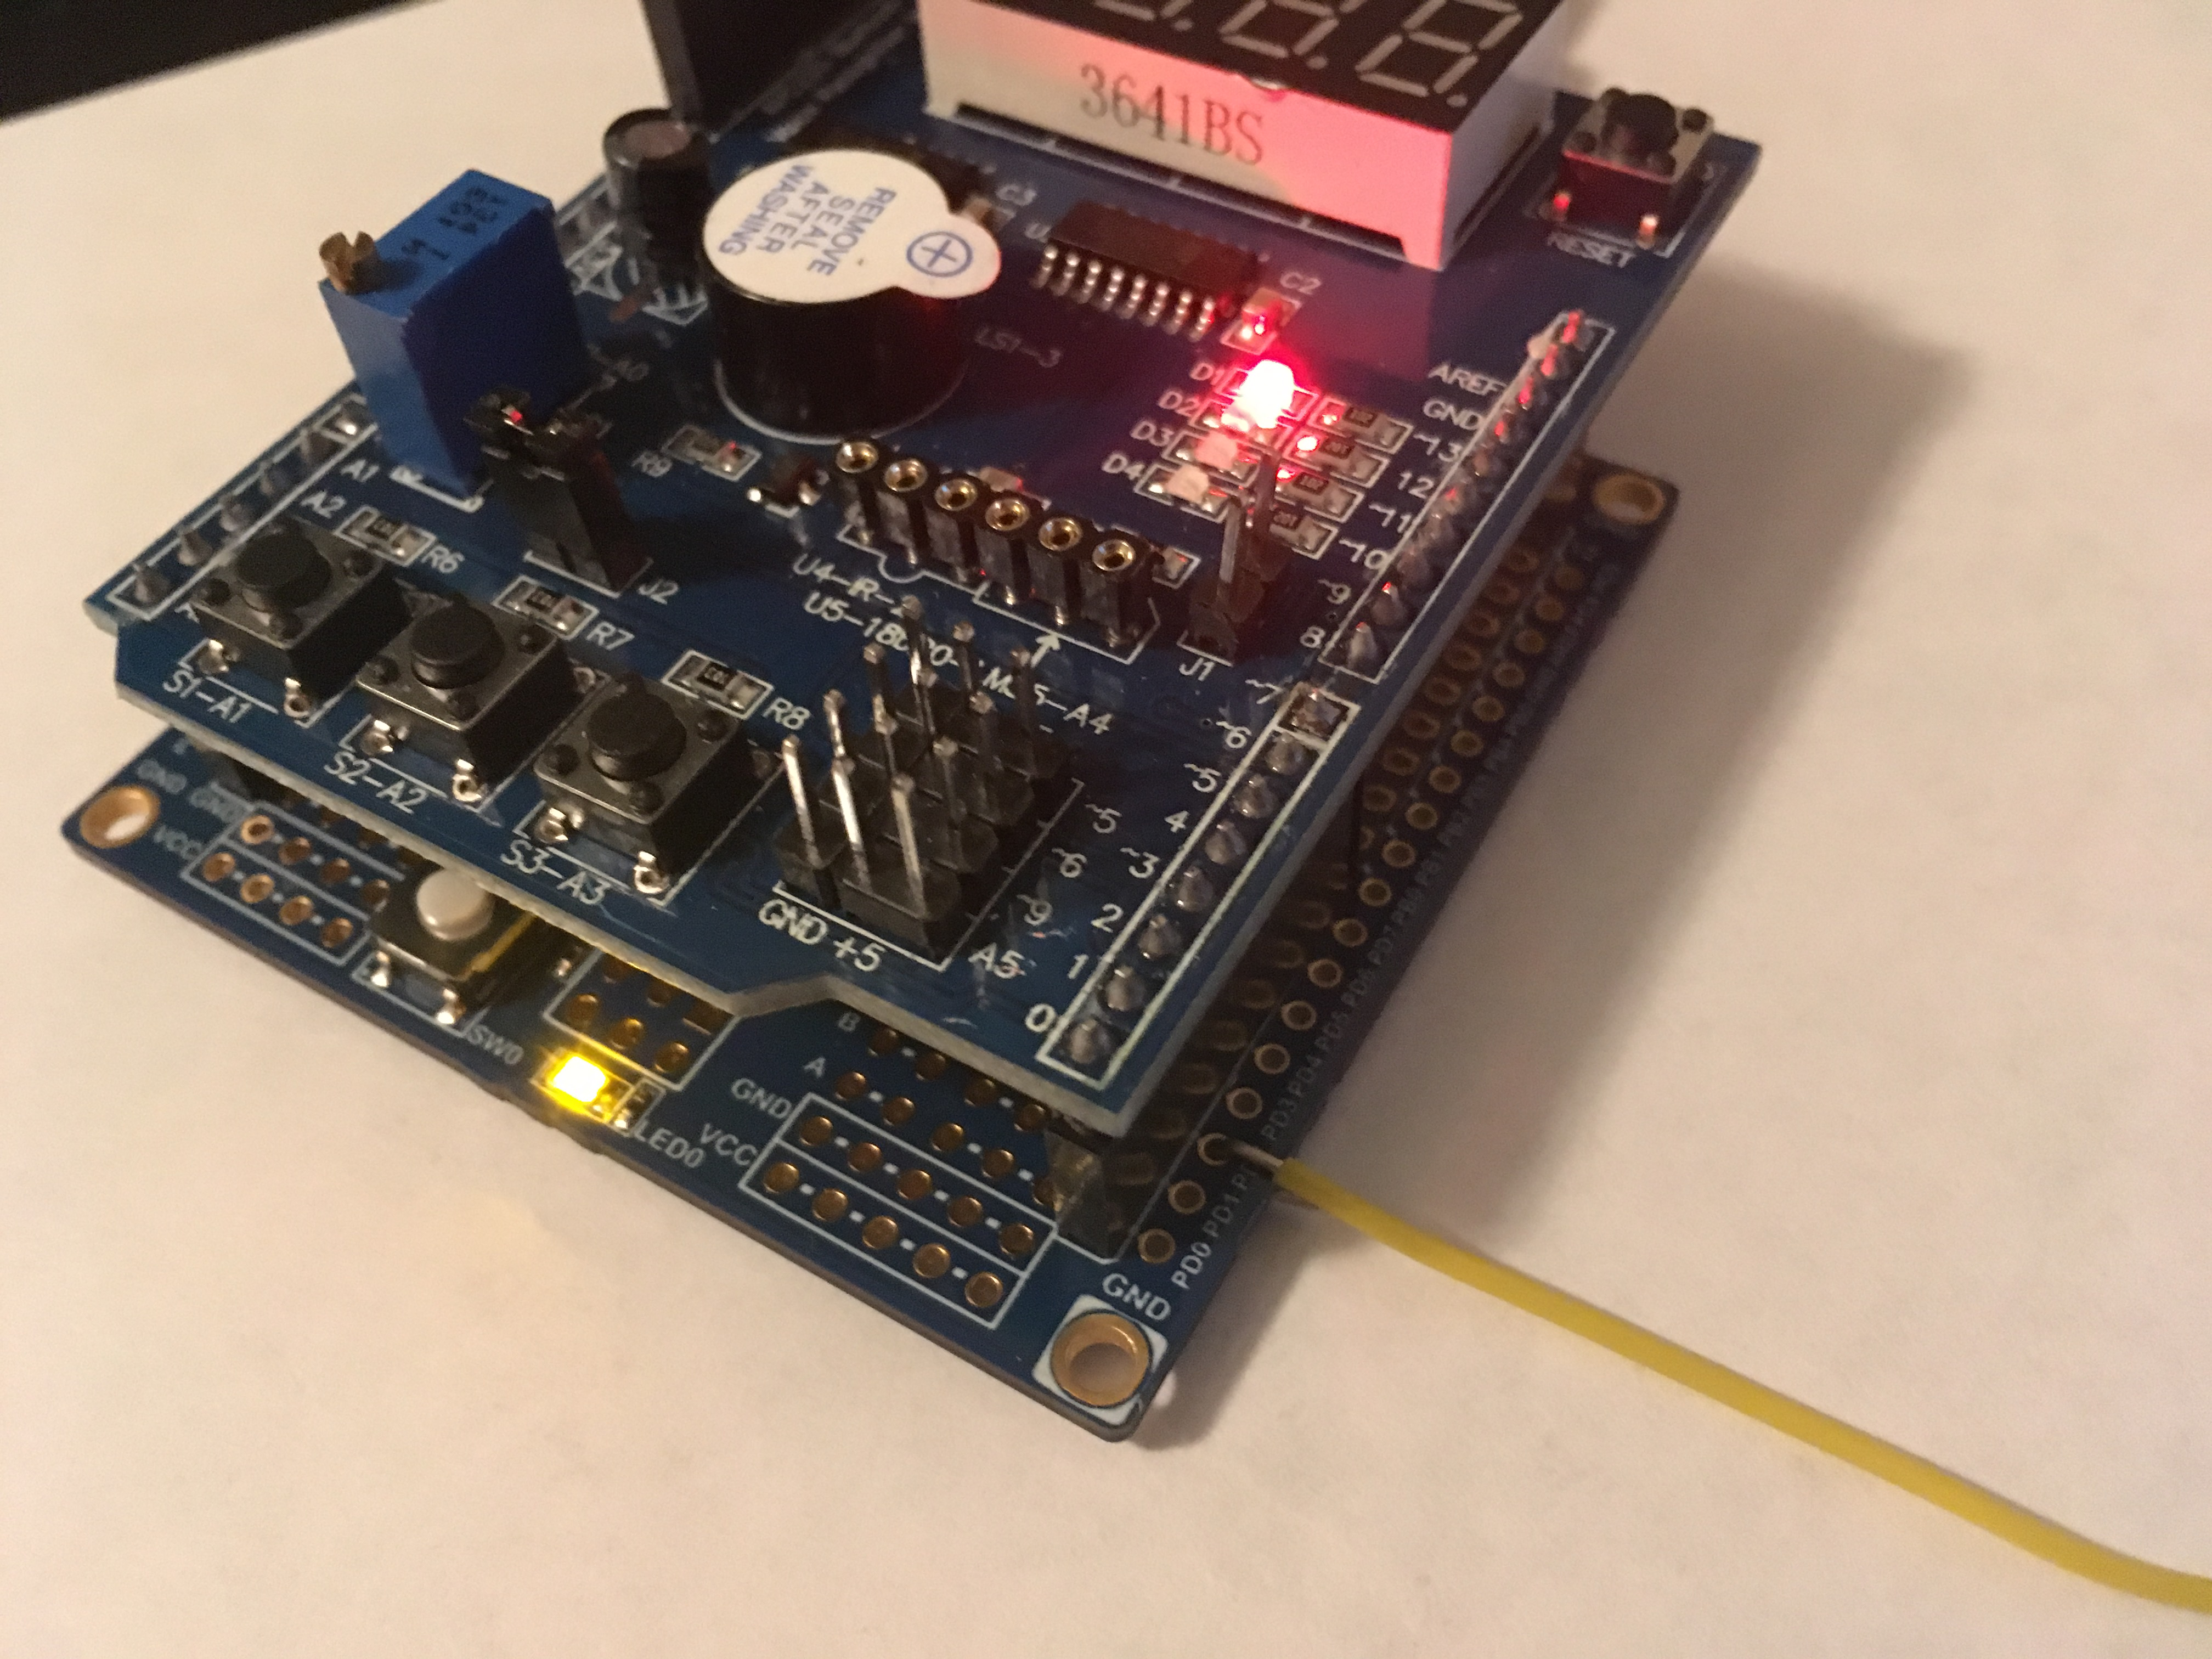

Board setup for Task 1 (Assembly and C), wire tied to PD.2 to connect to ground for external interrupt 0 (INT0)

1. **VIDEO LINKS OF EACH DEMO**

<https://youtu.be/rjn2Ocekjtw>

1. **GITHUB LINK OF THIS DA**

https://github.com/portig1/submissions_E/tree/master/DA/LAB2B

**Student Academic Misconduct Policy**

<http://studentconduct.unlv.edu/misconduct/policy.html>

“This assignment submission is my own, original work”.

Geovanni Portillo